**Chapter 21 – DAVID’S HEALTH PROBLEMS**

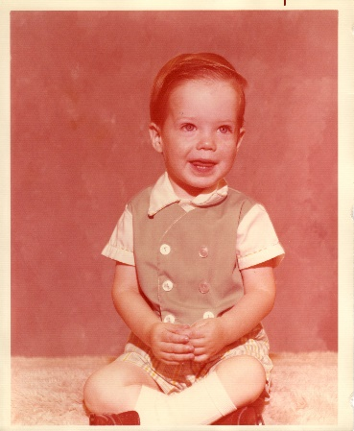

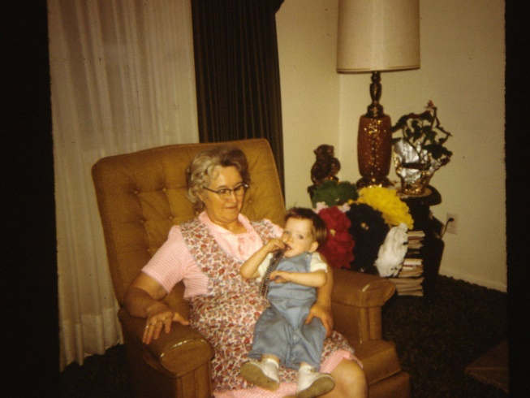 When David was about 18 months old, we had gone to Utah for Thanksgiving and he got sick while we were there. I took him to the doctor when we got home, and he said David had tonsillitis and ear infections and that he would need a "double" penicillin shot. (They used to give shots a lot in those days, now they mainly give liquid or pills) When the doctor told me that, immediately a terrible sensation came over me and the feeling that I shouldn't let David have the shot. I rationalized that when I was in Utah, Mom & her friend had been talking about penicillin and how you could have terrible reactions to it. Deep inside I knew it was the Holy Ghost warning me not to let the doctor give David the shot, but I guess I was weak and thought "well, he's the doctor and David is really sick, what else do I do?" Well, I let him have the shot and as I went out to the car, I fell apart and started crying because I knew that feeling was so strong that I shouldn't have let it happen, that I should have heeded the warning. David suffered terribly for several years because of that, and I suffered along with him and wished I could take the pain and other problems that came along with it, instead of him.

We did take him to another doctor to see if the doctor gave the shot in the wrong place. (Since David went into the medical field, he found out from another M.D. that the doctor had given it in the wrong place, and that the other doctor wouldn't "rat" on him as they cover for each other. We were told back then, that David was terribly allergic to penicillin and that if he had been 15 or older when he received the shot that he would never had walked again. The doctor said that if he should ever have penicillin again, it could kill him. He advised us to get a chain around his neck or a wrist bracelet showing that he was allergic to it, so in case he was taken to a clinic or hospital without us being there, that they would see it and not give it to him.

When I took David home from the doctor, who gave him the shot, he couldn't walk, it was too painful. He would scream as I changed his diaper, dressed him, put on his shoes, etc. It paralyzed his left side. The doctor said that with him being so young, it would heal an inch a month - so about a year later, the paralysis was gone, but it left him with a "club foot". We had taken David to all kinds of doctors to get help. One orthopedic surgeon had him do foot and leg exercises and come back each month. He would check it and tell us to continue doing these same exercises. We finally could see that it wasn't helping; all it was helping was the doctor's bank account, so we quit taking him there.

David not only had to contend with the paralysis and club foot, but he also still kept getting sick a lot. He coughed so much that he developed what they called a "chicken breast" (I think that was what it was called) Anyway, the bone in his chest protruded. The doctors kept putting him on antibiotics. I hated to have him have so many drugs and I couldn't see they were helping - only temporarily. It wasn't fixing the problem. We took him to an ear, nose and throat specialist who lived in our stake in Lehi. When I took David into his office, he said "that child needs his adenoid out". He could tell by the way he was breathing. He operated and took out his tonsils and adenoids and put tubes in his ears. That seemed to help for a while, but he was still sickly and it really worried me. He was going on four at this time. He got so bad that he would have coughing spells which started out just every so often. He would cough so hard at nights and couldn't breathe. Ken & I would prop his bed up so he could breathe easier, but it got progressively worse until we would be up most of the night with him for several nights in a row and then he would be so exhausted and weak that he would just lay around and not have any energy to do anything.

About this time Ken & I had been to a party that our Bishop's house. The Bishop's wife had been really sick for a long time and told me that she heard of a Dr. Swanstrom in Scottsdale who was a homoeopathic doctor and had helped so many people. She had gone to him and he put her on different vitamins, minerals, etc., and she couldn't believe the difference. She was afraid she was dying and now she was well. I was really interested, but soon forgot about it. My Mom & Dad had been down visiting for Thanksgiving or Christmas, I can't remember which and Ken's Mom & stepdad were also there. Dad & Leo gave David a blessing. I remember Sandi coming into the kitchen the next morning and saying "Mom, my grandpas gave David a blessing, why isn't he better?" She had heard him continue to cough so hard all throughout the night. I didn't have an answer for her then, but when she came home from school, I did. About 11:30 that morning, the thought came to me about Dr. Swanstrom and that I should take David to him. I called the Bishop's wife and got his phone number. I called and his wife told me that all his appointments were taken. She must have sensed how desperate I was as she let me talk to him. At first, he tried to make an appointment for a later date, but he also sensed my concern and told me to bring him right in. I later found out that he gave up his lunch hour to see David. When I carried David into his office, he took one look at him and said "I'm glad you brought him in, girlie". He always called me "girlie" from that time on. Dr Swanstrom was a cute little white-haired man who was in his 70's. He had studied to become a medical doctor, but had gone to Germany for more education. While there he learned about homoeopathic. He didn't get his M.D. because he believed more in homoeopathic. He even started a college in Chicago and worked there until he started having health problems because of working too hard and too long. He and his wife were religious. I can't remember what faith they belonged to, but he was their organist. He had a special gift from God and had a lot of faith in Heavenly Father. His wife was his receptionist and she also sold "Shackley" products. Her name was Dorothy and she was a very special lady also. He used a machine to test with, where you could use blood, saliva, or urine. He usually used saliva as it was the easiest. He would have you close your mouth on a paper towel. He would draw around it with a pen and test it with his machine. He also worked on your body - like a chiropractor, but much gentler. He would run his fingers down your spine and tell you not only what was wrong with your back, but other problems with your body. He would sell homoeopathic vitamins & minerals. They were little white pills which you would put under your tongue and dissolve. They tasted good - so it was not a problem to have the children take them. I loved this little old man and knew the Lord sent us to him.

Anyway, back to David. He told me that David was at a zero with oxygen - that was why he coughed so much and so hard, he didn't have hardly any oxygen in his body and thus no energy. He sent us home with iron, magnesium, calcium, etc. He also said his blood sugar was low and told me what to do.

When Sandi came home from school, I told her the Lord had blessed David - that Heavenly Father usually doesn't just immediately heal someone, but helps us to know what to do, and that he put the thought in my head to take him to Dr. Swanstrom which I had done and now he was going to get well. I had faith that this would be so. My parents had left that morning to go home, and Mom telephoned me later, that when they had left, she told dad that she didn't expect to see David alive again. She said he had been so sick and his skin was turning blue and she felt he wouldn't live much longer. I don't think he would have either, if the Lord hadn't blessed us to go to Dr. Swanstrom. After a couple of weeks and David was still having these coughing spells, I became impatient and again called Dr. Swanstrom. He told me that it had taken a long time for David to get this bad and it would take a while for him to get built back up. When he was feeling well again, I thanked Dr. Swanstrom and he said "Don't thank me, girlie, thank the Lord". He always gave the credit to the Lord. I know that was why he was able to help so many people. Over the years until Dr Swanstrom died, Ken & I went to him and took the family a lot too. When he first tested the other children, we had moved down and left the farm in Erda. He told us he hadn't tested such a healthy family in a long time. He told us that we must be feeding them good nutritious food, and taking good care of them. We told him we were health conscious and had always tried to get "whole" milk for the family to drink. If we didn't have a cow, then we tried to find someone who had one and buy milk from them. We also told him we just moved from a church farm where the children got lots of exercise and fresh air being out working and also playing on the farm.